40.22: (Also see Problem 40.25). The transmission coefficient is
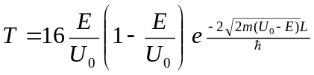with 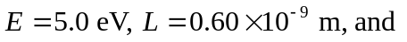
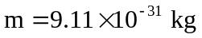
a) 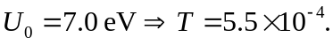
b) 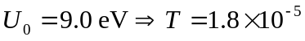
c) 